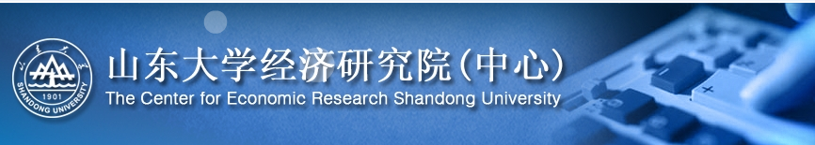
2011JOB OPENINGS
1. Brief introduction of the institution: Center for Economic Research, Shandong University
Center for Economic Research, Shandong University is one of the most leading research and education institutions for the property rights theory, institutional economics, law and economics, general equilibrium theory, econometrics, transitional economics, economic growth and business cycle theory, mathematical finance, financial organization and insurance theory, and microeconomics in China. Currently, CER has acquired the authorization of PhD’s Degree and Master's degree in all the fields of theoretical economics and applied economics. The current dean is Professor Dr. Huang Shao-an, a distinguished economist honored with “Cheung Kong Scholar”.
2. Job descriptions
Center for Economic Research invites applications for 2-3 full-time faculty positions starting from 2011. Candidates should be capable of teaching and specializing in one of the following subjects.
C - Mathematical and Quantitative Methods D - Microeconomics E - Macroeconomics and Monetary Economics
H - Public Economics
I - Health, Education, and Welfare
J - Labor and Demographic Economics
K - Law and Economics
L - Industrial Organization
O - Economic Development, Technological Change, and Growth
R - Urban, Rural, and Regional Economics
3. Minimum Level of Education Required: PhD
Candidates should hold a Ph.D. by the time of appointment in economics or a related discipline from leading universities.
3. Annual income
Candidates will receive competitive compensation packages with annual income about RMB200, 000 (negotiable), research starting fund and senior positions and job title (e.g. associate professor or professor).
4. Employment Interview
If you are interested in applying, please send a cover letter with curriculum vitae, samples of your written work, and three reference letters (including any teaching evaluations) to Dr. Huang Kainan (kennen@126.com).
5. Deadline of application
The official application deadline is May 30, 2011. However, applicants are strongly encouraged to apply as soon as possible for full considerations. Details of interview will be given to selected candidates in the subsequent emails.
6. Contact Information
For more information, please feel free to contact
Dr. Huang Kainan
Email: kennen@126.com
Tel: 86-531-88364000; MP: 86-15853123850; Fax: 86-531-88364981
27 Shanda Nanlu, Center for Economic Research, Shandong University, Jinan, P.R.China 250100
www.cer.sdu.edu.cn

