Transportation Survey Forms:
If you take a flight to Chengdu, please fill out the form below, and email the filled form to sumingtao@swufe.edu.cn；

Name | Gender | Email Address | Arrival Information （Chengdu Shuangliu International Airport)
Name | Gender | Email Address | Date & Time of Arrival | Flight Number | Terminal Number |  | Departure City  (when you arriving in Chengdu) | Number of Companions
 |  |  |  |  | T1 | T2 | Departure City  (when you arriving in Chengdu) | Number of Companions

*If you have any problem, please contact Mr Mingtao Su.
Mobile Phone Number: +86 138 8017 5354 or +86 189 8171 7927
Email Address: sumingtao@swufe.edu.cn

Transportation FQA：
Q1: What if you missed the shuttle bus arranged by us at Chengdu Shuangliu International Airport?
You have two options:
1. Take bus No. 300 to Chengdu North Railway Station, and then take the high-speed rail to Qingcheng Mountain Station. The Qingcheng Mountain station is next to the hotel.
*Information of Bus No. 300
Service Time | Ticket Price (RMB)
06：30AM～20：00PM | 10

2. Or take the Airport Express to Minshan Hotel, and then transfer to Chengdu Metro Line 1 to Chengdu North Railway Station. Take the high-speed rail at Chengdu North Railway Station to Qingcheng Mountain station. The Qingcheng Mountain station is next to the hotel.
*Information of Airport Express
Service Time | Ticket Price (RMB)
According to the time of flight arrivals | 10
*Information of Chengdu Metro Line 1
Service Time | Ticket Price (RMB)
06：30AM～23：00PM | 2-5

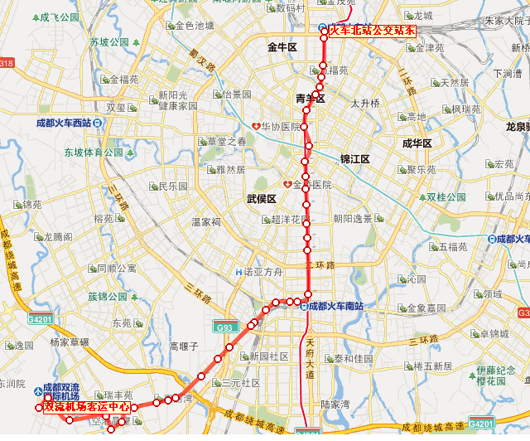

Q2: If you took the train and arrived at Chengdu North Railway Station, how to reach the hotel?
Please take the high-speed railway at Chengdu North Railway Station to Qingcheng Mountain Station.

Q3: If you took the train and arrived at Chengdu East Railway Station, how to reach the hotel?
Please take Chengdu Metro Line 2 to Tianfu Square station and exchange to Chengdu Metro Line 1 over there to Chengdu North Railway Station. Take the high-speed rail at Chengdu North Railway Station to Qingcheng Mountain station. The Qingcheng Mountain station is next to the hotel.

*Information of Chengdu Metro Line 2
Service Time | Ticket Price (RMB)
06：30AM～22：00PM | 2-5
*Information of Chengdu Metro Line 1
Service Time | Ticket Price (RMB)
06：30AM～23：00PM | 2-5

Appendix: Timetable of High-speed Railway
票价  Ticket Price （RMB） | 车次  Train Number | 发站Departure  Station | 到站  Arrival  Station | 发时—到时  Time of Departure and Arrival | 运行时间  Travel  Time | 距离  Distance
15 | D6101 | 成都火车北站  Chengdu North Railway Station | 青城山  Qingcheng Moutain | 07:01—07:50 | 49 min | 65KM
15 | D6103 | 成都火车北站  Chengdu North Railway Station | 青城山  Qingcheng Moutain | 07:30—08:14 | 44 min | 65KM
15 | D6105 | 成都火车北站  Chengdu North Railway Station | 青城山  Qingcheng Moutain | 08:33—09:23 | 50 min | 65KM
15 | D6107 | 成都火车北站  Chengdu North Railway Station | 青城山  Qingcheng Moutain | 09:03—09:53 | 50 min | 65KM
15 | D6109 | 成都火车北站  Chengdu North Railway Station | 青城山  Qingcheng Moutain | 09:31—10:21 | 50 min | 65KM
15 | D6111 | 成都火车北站  Chengdu North Railway Station | 青城山  Qingcheng Moutain | 11:52—12:34 | 42 min | 65KM
15 | D6113 | 成都火车北站  Chengdu North Railway Station | 青城山  Qingcheng Moutain | 12:25—13:10 | 45 min | 65KM
15 | D6115 | 成都火车北站  Chengdu North Railway Station | 青城山  Qingcheng Moutain | 13:23—14:13 | 50 min | 65KM
15 | D6117 | 成都火车北站  Chengdu North Railway Station | 青城山  Qingcheng Moutain | 13:50—14:39 | 49 min | 65KM
15 | D6119 | 成都火车北站  Chengdu North Railway Station | 青城山  Qingcheng Moutain | 14:17—15:06 | 49 min | 65KM
15 | D6121 | 成都火车北站  Chengdu North Railway Station | 青城山  Qingcheng Moutain | 15:48—16:29 | 41 min | 65KM
15 | D6123 | 成都火车北站  Chengdu North Railway Station | 青城山  Qingcheng Moutain | 16:47—17:23 | 36 min | 65KM
15 | D6125 | 成都火车北站  Chengdu North Railway Station | 青城山  Qingcheng Moutain | 17:36—18:25 | 49 min | 65KM
15 | D6127 | 成都火车北站  Chengdu North Railway Station | 青城山  Qingcheng Moutain | 18:39—19:28 | 49 min | 65KM
15 | D6129 | 成都火车北站  Chengdu North Railway Station | 青城山  Qingcheng Moutain | 19:41—20:30 | 49 min | 65KM
15 | D6131 | 成都火车北站  Chengdu North Railway Station | 青城山  Qingcheng Moutain | 20:17—20:53 | 36 min | 65KM

